[](http://www.decalsandstickers.co.uk/catalog/images/crane-bird_chinese_Kanji.jpg?osCsid=7b1b1ef25b54b64d67faf55c219e8380)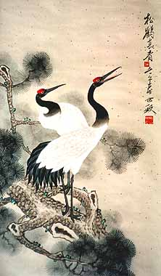[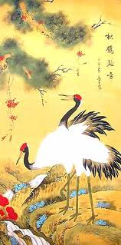](http://www.google.co.uk/imgres?imgurl=http://www.the-gallery-of-china.com/chinese-crane-painting-CR5846.jpg&imgrefurl=http://www.the-gallery-of-china.com/chinese-crane-painting-15.html&usg=__qAA8Vr-x1qZxyFZKnZmeZ0Udf5E=&h=480&w=238&sz=40&hl=en&start=1&zoom=1&tbnid=Mv3ilRmY9Vw9rM:&tbnh=129&tbnw=64&ei=IKOdTdfhDcvWsgbKsI2tBA&prev=/images?q=chinese+crane&hl=en&safe=strict&biw=1276&bih=823&gbv=2&tbm=isch&itbs=1)[](http://www.google.co.uk/imgres?imgurl=http://www.amazing3dmodels.com/store/images/uploads/9/Chinese-Flag-main.jpg&imgrefurl=http://www.amazing3dmodels.com/store/miscelaneous/chinese-flag-zip/prod_370.html&usg=__UXubDgkmaeHY_rkSlLnK6_7GByU=&h=400&w=400&sz=43&hl=en&start=6&zoom=1&tbnid=VIQ2o8ik6EtDyM:&tbnh=124&tbnw=124&ei=UaCdTYXVMcXusgbqi72eBA&prev=/images?q=chinese+flag&um=1&hl=en&safe=strict&biw=1276&bih=823&tbm=isch&um=1&itbs=1)

The Crane is famous for it’s mating dance which includes loud calling, flying majestically and swimming!

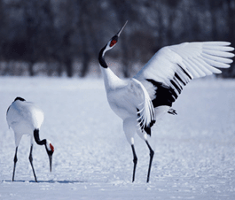

The Chinense Crane has long nearly black (but brown) legs and an extended neck for fishing and speed when they are flying.

The Chinese crane is a symbol of long life, happiness, marital fidelity, and love. ☺

This is the Chinese cranes mating dance…Males are usually more colourful than females so that they would stand out in mating season.

This is where you find the cranes most in the world. As you can see they mostly live in the regions of China.

By Vianca* Razon