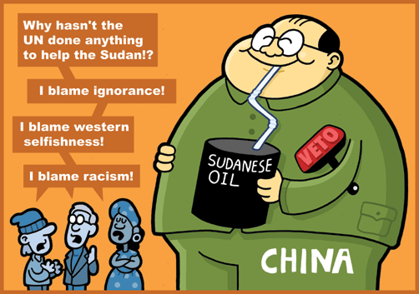
Oil for China, Guns for Darfur

A new report by a nongovernmental organization links Beijing's access to Sudan's oil with China's sale of small arms used in the Darfur conflict
China's thirst for oil is causing bloodshed. So says New York-based nongovernmental organization Human Rights First, which on Mar. 13 released a report linking China's rising imports of Sudanese oil with sales of Chinese small weapons to Khartoum, used to further the deadly conflict in the western region of Darfur. The report is part of a broader campaign called Made in China: Stop Arms Sales to Sudan, timed to coincide with the runup to the Beijing Olympics in August. "China's huge appetite for oil from Sudan filled Khartoum's coffers, enabling Sudan to buy Chinese arms," says Betsy Apple, a Human Rights First program director and author of the report. "It's a toxic oil-for-arms relationship." Apple says the group is calling for China to halt arms sales to Sudan immediately.
At issue is the simultaneous growth of Sudanese oil exports to China and the proliferation of Chinese small weapons in Darfur. When it comes to oil consumption, China is second only to the U.S. and almost half of China's oil needs come from imports. The Chinese rely on Sudan to supply a big part of that. Sudanese oil shipments to China increased 63% from 2003 to 2006 and soared 113% last year alone. In 2007, China purchased 40% of Sudan's 25-million-ton annual output of oil, accounting for about 6% of all Chinese oil imports (BusinessWeek.com, 2/13/08). State-owned China National Petroleum (CNPC) is the single largest investor in Sudan through its 40% stake in Greater Nile Petroleum, based in Khartoum. Beijing has also been investing heavily in improvements to Sudan's infrastructure. For instance, the Chinese have pumped hundreds of millions of dollars into roads, pipelines, and other infrastructure projects.

Protests Against Darfur Violence Grow
Critics of the Sudanese regime contend that Chinese money is also supporting the country's military and its militia allies in Darfur. Human Rights First argues that, in return for access to oil fields to help motor its growing economy, China provides Sudan with Chinese weaponry such as assault rifles, heavy machine guns, and mortars. China not only is Sudan's largest economic partner, but also its "military mentor, advising its army and giving it guns," says the report. Citing U.N. and Sudanese government data, the report states that China sold $3 million in small arms to Khartoum in 2003; that number reached more than $55 million by 2006. Beijing denies charges that it is exacerbating the problem, arguing that China was the first non-African nation to send peacekeepers to Darfur. (There are 140 Chinese there now with another 175 scheduled to join them soon.) "We just want to send signals to Sudan and the outside world that the Chinese people and their government are sympathetic with the people there in Darfur.. China has given $11 million in humanitarian aid to the region, Xinhua reports, and is providing $90 million in loans for water projects there.

