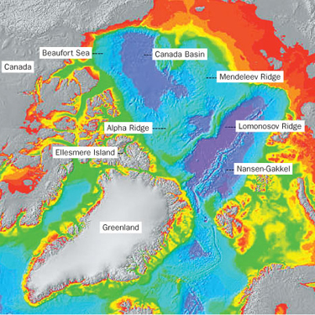
Research backs Canada's Arctic claim

There will be no flag-waving or patriotic chest-thumping, but Canadian scientists are quietly set to make one of this country's most important assertions of Arctic sovereignty in decades tomorrow at a geology conference in Norway.
A year after Russian scientists planted their nation's flag on the North Pole seabed -- a controversial demonstration of their country's interest in securing control over a vast undersea mountain chain stretching across the Arctic Ocean from Siberia to Ellesmere Island and Greenland -- the Canadian researchers have teamed with Danish scientists to offer proof that the Lomonosov Ridge is, in fact, a natural extension of the North American continent.
Their landmark findings, the initial result of years of sea floor mapping and millions of dollars in research investments by the Canadian and Danish governments, are to be presented at the 2008 International Geological Congress in Oslo under the innocuous title "Crustal Structure from the Lincoln Sea to the Lomonosov Ridge, Arctic Ocean."
But the completion of the study represents a key step in Canada's effort to eventually win rights over thousands of square kilometres of the polar seabed, a potential treasure trove of oil and gas being made more and more accessible as melting ice unlocks our High Arctic frontier.The stakes are so high that the Canadian and Danish governments set aside their differences over the ownership of Hans Island.Along with Russia, both Canada and Denmark are preparing submissions under the United Nations Convention on the Law of the Sea (UNCLOS) to secure jurisdiction over large swaths of the Arctic Ocean sea floor adjacent to their coastlines.
To secure those rights, each country has to submit scientific evidence proving the claimed undersea territories are linked geologically to its mainland or its Arctic islands.Canada's planned UNCLOS submission includes areas in the Beaufort Sea in the western Arctic, on the Lomonsov Ridge in the east and along another underwater Arctic mountain range in the central Arctic called Alpha Ridge.The Canadian-Danish study of the Lomonosov Ridge is to be presented in Oslo by Danish researcher Trine Dahl-Jensen and four scientists from the Geological Survey of Canada: Ruth Jackson, Deping Chian, John Shimeld and Gordon Oakley.
The study describes various geological traits observed by the two countries' scientists -- including magnetic anomalies, crust characteristics and volcanic features -- that appear common to both the ridge and adjacent parts of Canada and Greenland.
As a further sign of the intensifying interest in the Lomonosov Ridge and its potential petroleum riches, a Russian study being presented at the Oslo congress explores Lomonosov-Siberian connections and a study by the U.S. Geological Survey examines the ridge's oil and gas potential.

