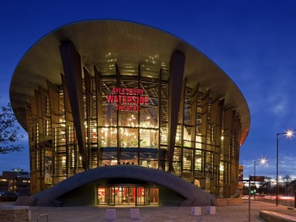
Case study: Regeneration in Aylesbury

Aylesbury is in the county town of Buckinghamshire. Led by Aylesbury Vale District Council, the waterside redevelopment project begun in 2003 with a canal based regeneration scheme to replace the Bucks Herald Printing press, police station and old county offices. The development was delayed by the Environment Agency due to the contamination of some land.

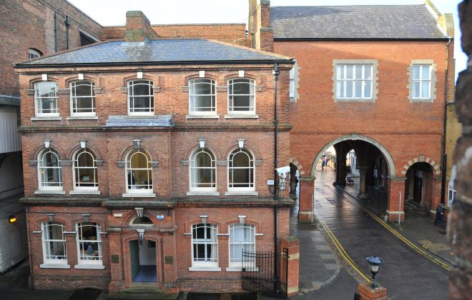
The 1st phase saw the demolition of a 1960’ car park and the construction of £46 million Waterside Theatre and the Aylesbury campus for Bucks New University, the first tertiary provider in the town. A Waitrose, Nandos and Gourmet Burger Kitchen have set up. There has also been a 2.2 % increase in football since 2013 since the changes. There are plans for more restaurants and shops but there has been resistance from restaurants and shops in the town centre.

The most recent phase saw the demolition of some historic buildings. Following a campaign by the Aylesbury Society the Court buildings and Judges Lodges (listed buildings) have been converted into hotels and restaurants, one themed on Ronnie Biggs and the Great Train robbery which happened nearby. The plans for regeneration are now focused on the surrounding landscape to facilitate better pedestrian and transport access.
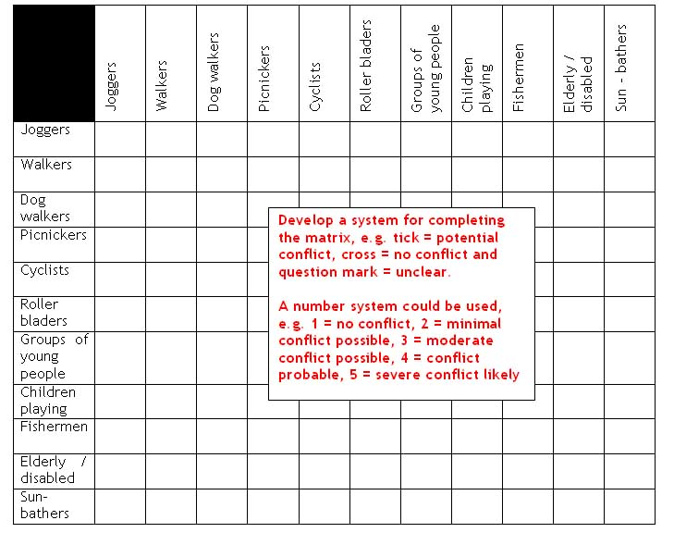
- Set up a conflict Matrix between the players (those underlined above). The matrix should look like the example.
- For each player decide if they would be in favour of Aylesbury regeneration plans. Colour in the square green for agreement, red disagreement and orange for might/might not disagree.
- Which groups want to preserve the environment and which would seek change?

