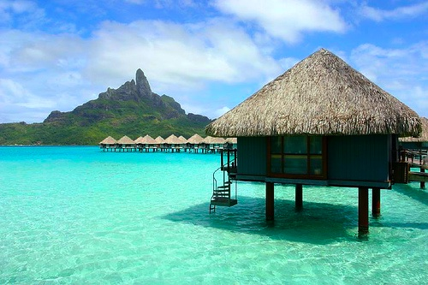
Coasts & Climate Change
40% of people on Earth live within 100km of the coast worldwide. Issues such as rapid sea level rise, increasing magnitude and frequency of storms and associated increases of coastal erosion all pose a threat to their lives and property.
This homework has been set to give you the opportunity to complete some independent research and find out about a place that is under threat from climate change. To get you started here is a list of places that you could find out about:
Kiribati | Netherlands | Bangladesh
Maldives | Venice | Egypt
Tuvalu | United Kingdom | South Africa

You are to produce an A3 factfile describing and explaining why your coastal location is under threat. You should also explain how they are trying to cope with any problems. The report should meet the following criteria:
- Written using Microsoft Word or similar application
- A3
- Font Size 14
- Include some relevant images
- Location Map is essential
- Rates of erosion/Sea level rise predictions
- Describe current/future threats
- Explanations of attempts to manage threats
As ever with this homework a deadline will be provided during lessons and will vary depending on your classroom teacher. Be as creative as possible with deisgn.
You can send completed work to my school e-mail or bring it in on a USB drive and we can print it off in colour for you.

