**UNIT 5: CONTRASTING COASTS**

**THE COASTAL ZONE** = the zone between the land and sea.

Coasts are always changing.

**Advantages of living by the coast:**

* Fish
* Good agricultural land found next to the coast
* Access for trade
* Tourism opportunities
* Recreation

EROSION: The process of wearing the cliffs away.

ATTRITION

Two rocks crash into each other and break down into smaller pieces.

ABRASION

Rocks are hurled against the cliff. They scour away like sandpaper.

HYDRAULIC ACTION

The power of water/waves forced into cracks and forcing the rocks apart

Some rocks are very resistant to erosion e.g. granite.

Some rocks are least resistant e.g. clays and will erode quickly.

**Coastal Landforms…**

Wave Cut Notch/Platform

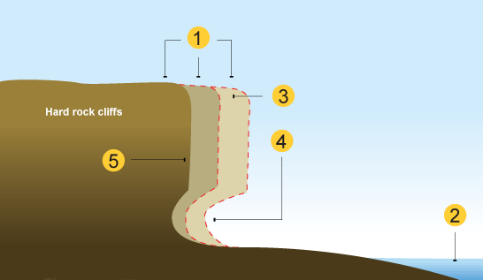

1. The sea attacks the base of the cliff forming a wave-cut notch.
2. The notch increases in size causing the cliff to collapse.
3. The process repeats and the cliff continues to retreat.
4. A wave cut platform is left at the bottom. Exposed at low tides.

Caves, Arches, Stacks and Stumps…

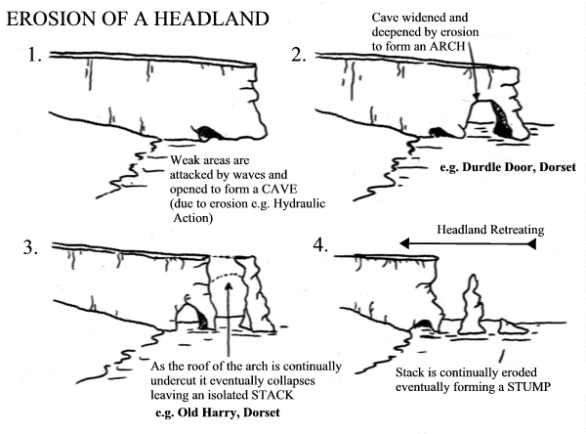

ROCK STRUCTURE = the way rock types are arranged. Usually in layers (strata).

Concordant and Discordant coastlines:

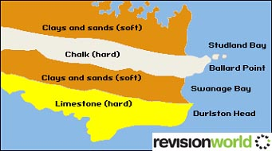

DISCORDANT coastline – different layers of rock at right angles to the coast.

CONCORDANT coastline – the rock type is the same along the whole coastline.

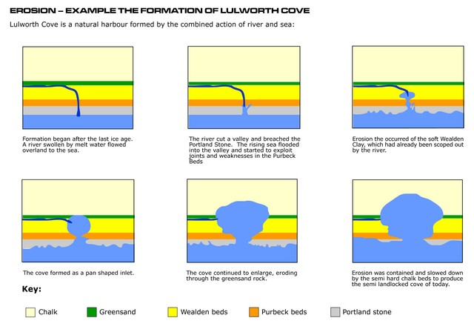NAMED EXAMPLE: Concordant coast: lulworth cove

NAMED EXAMPLE: DISCORDANT COAST: HEADLANDS AND BAYS, S.W. IRELAND

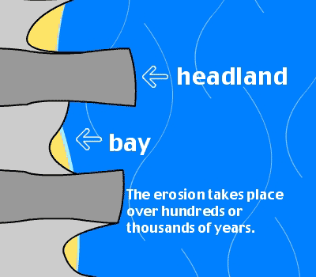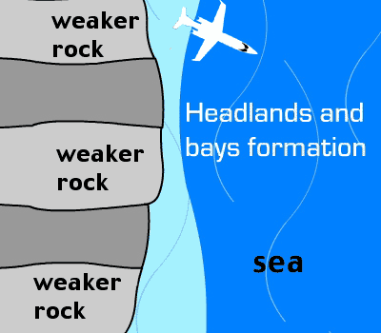

The weaker rock here is limestone. The hard rock here is sandstone. The soft rock erodes much faster than the hard rock creating bays. The more resistant rock is left sticking out as headlands.

**Weaknesses in the rock can be:**

* JOINTS: small, natural cracks
* FAULTS: larger cracks caused in the past by tectonic movements

**Waves…**

The wind blows across the sea. Friction between the wind and water creates waves. The size of the waves depends on:

* The strength of the wind
* How long the wind blows for
* 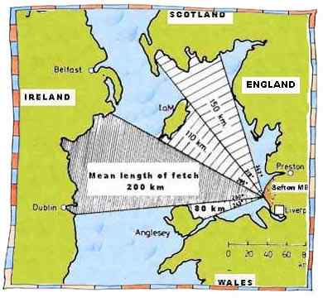The length of water the wind lows over (the fetch). This is why Cornwall has the biggest waves in England.

Wave length and amplitude…

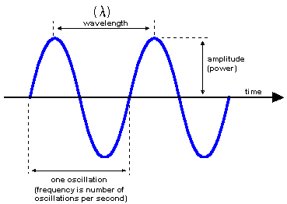

CREST

TROUGH

**How waves break…**

* 1. Out at sea the wind creates a wave shape.
  2. Within a wave each water particle moves in a circular movement and returns to the start. It is only energy and not the water itself that is moving forward.
  3. When the wave reaches shallow water the wave is distorted from a circular shape to an ellipse shape until it becomes so top heavy that it ‘breaks’.
  4. it is now not only energy but also water that moves forwards.

**Swash and backwash…**

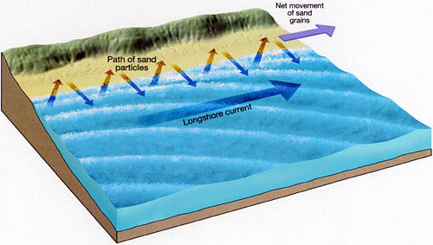

The waves come up the beach (swash) in the direction of the prevailing wind.

The waves go back down the beach (backwash) at right angles due to gravity.

**Summer waves = constructive waves:**

* small
* long wavelengths
* low amplitudes
* strong swash so transport sand up the beach and deposit it – builds up the beach.

**Winter waves = destructive waves:**

* taller (larger amplitude)
* closer together (shorter wavelength)
* plunging waves = dangerous as are so quick the backwash has to flow under the incoming wave = rip current = dangerous to swimmers as can drag them out to sea.
* strong backwash – erodes sand from the beach and carries it out to sea where it is deposited.
* Steep beach is formed

**Coastal landforms of deposition…**

SEDIMENT = tiny clay particles, sand, silt, pebbles, boulders.

**Longshore Drift…**

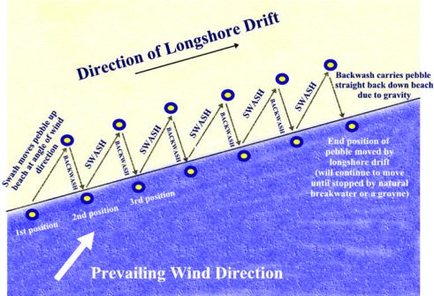

The particles of sand or shingle are transported along the beach in a zig zag movement, carried by the swash and backwash. As the prevailing wind is usually in the same direction so LSD usually is too.

**Sand Dunes…**

Strong onshore winds blow the sand inshore.

**Spits…**

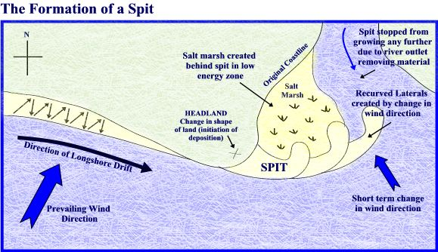

* At a corner in the coastline LSD continues to deposit out to sea forming a neck of sand and shingle.
* The end is curved round by the wind and waves.
* Salt marsh forms in the shelter of the spit.

**Tombolo…**  **Bar…**

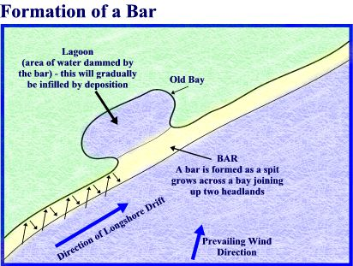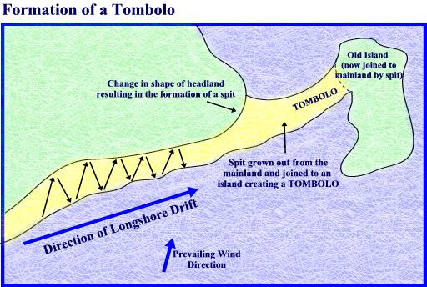

A tombolo is where the sediment joins the mainland to an island.

A bar joins two sections of mainland.

**Sand Dune Plants…**

Plants that grow on the sand dunes need to be tough…

* Long roots to hold them in place during strong winds
* Tough, waxy leaves
* Can survive being sprayed with salt water
* E.g. marram grass

**Coasts and the Changing Climate…**

With increasing sea levels due to thermal expansion (water particles expand as they warm up) and the melting of the ice sheets. Low lying coastlines e.g. Bangladesh, Essex, Pacific islands = at risk.

**STORM SURGES:**

* The gravity of the moon creates tides. Twice a day we have high tides which gives raised sea levels.
* A few times a year we have ‘spring tides’ which are very high.
* If a spring tide and low air pressure coincide = a STORM SURGE = huge waves flooding the coast.
* Global warming could make depressions more powerful and therefore storm surges more common.

🡪 Higher sea levels and more storms would = faster erosion rates.

🡪 Current sea defences would be useless and we would have to spend a lot of money on new ones.

**Why do cliffs collapse?**

1. MARINE (sea) processes – the base of the cliff is eroded by hydraulic action and abrasion.
2. SUBAERIAL processes – weathering and mass movements – weathering (the breakdown of rocks where they are) = freeze thaw, chemical. Mass movements (movement of materials downslope) 🡪 heavy rain saturates the rock. The water infiltrates and adds weight to the cliff, making it unstable.
3. 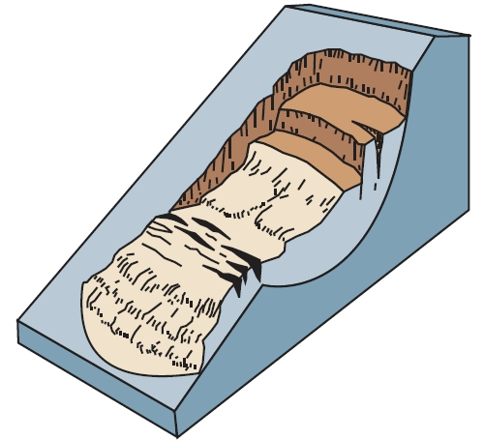HUMAN ACTIONS – building on the top of the cliff – heavy load pushes down on the cliff.

During a big storm heavy rain saturates permeable rock. There is erosion by the sea aswell 🡪 a chunck of cliff gives way and slides down the cliff as a ROTATIONAL SLIDE.

NAMED EXAMPLE: CHRISTCHURCH BAY, BARTON-ON-SEA, S.COAST UK.

* SW winds have a 3000 mile fetch across the Atlantic.
* Bad weather, cliff foot erosion, weathering, heavy rain and building at the top of the cliff…

IMPACTS:

* Homeowners could lose their homes to the sea. House values fall. Insurance money may be impossible to get.
* Rapid cliff collapse = dangerous.
* Some roads and infrastructure = destroyed.
* Unattractive.

🡪the people of Christchurch Bay argued that they needed sea defences…

**Coastal Management…**

**HARD ENGINEERING** – traditional, building structures, costly, ugly.

**SOFT ENGINEERING** – working with nature. Cheaper, less intrusive.

**SEA WALLS**

* 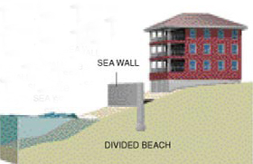reflect the waves back out to sea
* Costly
* Makes it hard to access the beach
* The wall itself erodes = high maintenance costs.

**GROYNES**

* 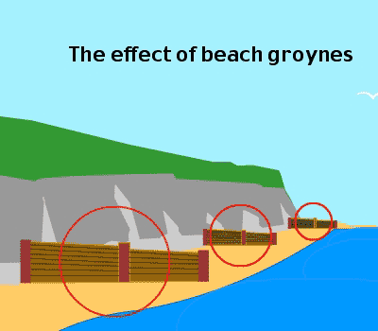Trap and stop the longshore drift from moving along. Builds up a nice big sandy beach. This is the best form of protection against erosion – the wave moves around every grain of sand, taking lots of energy out of the wave (energy is dissipated).
* Good for tourism
* Has a negative impact down the coast which is starved of sediment – here the beach becomes smaller and offers less protection so erosion rates increase greatly. This = conflict.

**ROCK ARMOUR/RIP RAP**

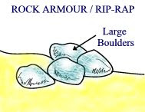

* Big boulders placed at the base of the cliff – dissipate the energy of the waves.
* Looks natural.
* Makes access to the beach difficult.
* Can be hard to transport the boulders into position.

**CONFLICT…**

|  |  |
| --- | --- |
| FOR HARD ENGINEERING | AGAINST HARD ENGINEERING |
| * Locals want hard engineering – it looks like something serious is being done to protect them. * Local businesses e.g. caravan parks, hotels. * Local politicians who want the residents support. | * Local taxpayers who don’t live at the coast. * Environmentalists – worry about habitats being destroyed. * People who live down coast🡪 negative effects. |

**Modern management…**

**Holistic management** 🡪 managing the whole stretch of coast and not just one place. Holistic management takes into account:

* The needs of different groups of people
* Economic costs and benefits
* The environment of land and sea

**ICZM** – Integrated Coastal Zone Management

**SMP** – Shoreline Management Plans – for long stretches of coast. This should stop one place building groynes if it will effect down the coast.

**Council choices…**

Councils have 4 choices of how to manage the coast:

1. HOLD THE LINE: use defences to stop erosion and keep the coast where it is. Expensive.
2. ADVANCE THE LINE: move the coast further into the sea. Very expensive.
3. STRATEGIC RETREAT: gradually let the coast erode and move people/businesses away as necessary. Compensation has to be paid.
4. DO NOTHING: let nature take its course.

NAMED EXAMPLE: North Norfolk coast

|  |  |  |  |  |
| --- | --- | --- | --- | --- |
| Hold line | Do nothing | Hold line | Maintain existing defences. Strategic retreat when these fail | Do nothing |

Mundesley Walcott Happisburgh

**Soft engineering approaches:**

* Planting vegetation – make the cliff more stable
* Beach nourishment – pump sand onto the beach, having dredged it from under the sea, to make a nice big sandy beach. Has to be maintained as LSD moves the sediment down the coast all the time.
* Offshore breakwaters – force the waves to break before they reach the beach.
* In cliff drainage to prevent saturation.

Some places are not protected as…

* Too expensive to
* The value of the land/buildings doesn’t justify the cost
* Defences may cause erosion down coast
* May be impossible to soon due to global warming and sea level rise.

In some places defences are being abandoned and nature let take its course.

🡪 at the moment the government thinks it is too expensive to protect farmland/isolated houses.

🡪 conflict

🡪 hard to convince people who’ve lived there all their lives that protecting their property is not sustainable.

🡪 We don’t know the impact rising sea levels will have so planning new defences is difficult.