Geography GCSE: Extended Writing
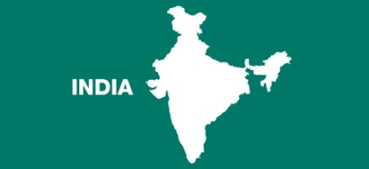
Use the writing frames below to produce a series of detailed responses on key issues from the India Unit. These are exam style questions!

Q1. Explain how the Indian government and globalisation has influenced recent economic growth (8 marks)
India is now the fastest growing economy on Earth.
One reason for this growth is due to … .
This has increased economic growth because…
A second factor for this growth is due to…
This has increased economic growth because…
A third factor for this growth is due to ….
This has led to increased economic growth because…

Possible Factors:
- Government Policy: Science & Education (think improved workforce)
- Aid : Receiving/Donating/Technical Assistance
- Service Sector: Outsourcing/Software Exports/Tourism
- Investment in Transport: Trade
- FDI: Business investment in India (explain why India attracts FDI)

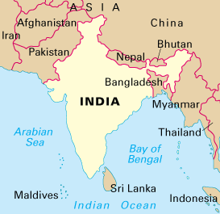
Q2. Describe the geographical location of India (6 marks)
You should mention:
- Continent (Is India in NESW?)
- Longitude/Latitude
- Bordering nations
- Oceans/Seas/Bays

Q3. How has India’s physical geographical position influenced it’s economic growth in the region? (4 marks)
(think about its central location and its coastline)
One physical reason for its rapid economic growth is that it has…

This has influenced its economic growth because…

Another reason for India’s rapid economic growth is that it has..

This has influenced its economic growth because…

Q4.Explain how India’s economic growth has led to environmental impacts (12 marks)
One environmental impact of economic growth is …
The evidence for this environmental impact is…
This is caused by a number of factors such as…
(make sure you fully explain the causes eg increased vehicle emissions because of more car ownership because more people working in factories which means more income which means they can afford more cars)
Repeat this structure for 3 main paragraphs/ roughly 4 marks per paragraph
Make sure you include evidence!
THINK: AIR/WATER/DEFORESTATION!
Q5. Compare the growth rates of India and China. (4 marks)
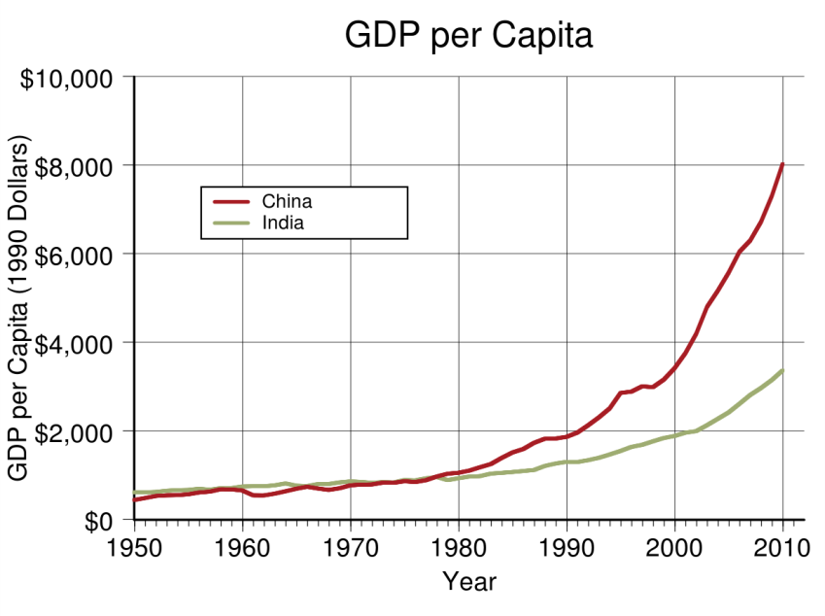

- you need to say which is bigger or growing faster
- you need to refer to figures in your answer

